CREATE AN ACCOUNT IN FAST2SMS DASHBOARD

|  |  |
| --- | --- |
| Date | 18 November 2022 |
| Team ID | PNT2022TMID51214 |
| Project Name | Smart farmer- IOT enabled smart farming  application |

**FAST TO SMS**

Fast2SMS is on a mission of making the SMS Industry simple, transparent and less costly. Our Bulk SMS platform designed to help small to large business owner who want to send promotional, marketing, OTP, multimedia & alerts SMS.

# Step 1:

# Click Dev API

# Give route as Quick SMS

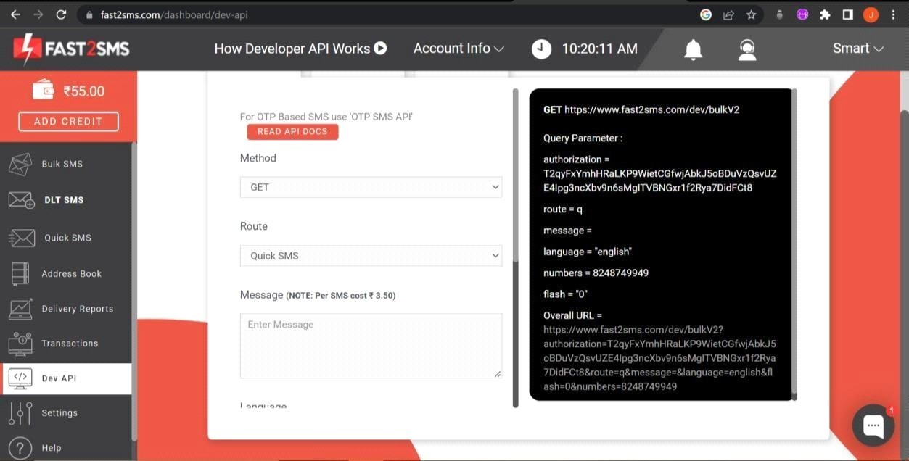

# Step 2:

# Give the contact number which is needed.# Copy the url generated.

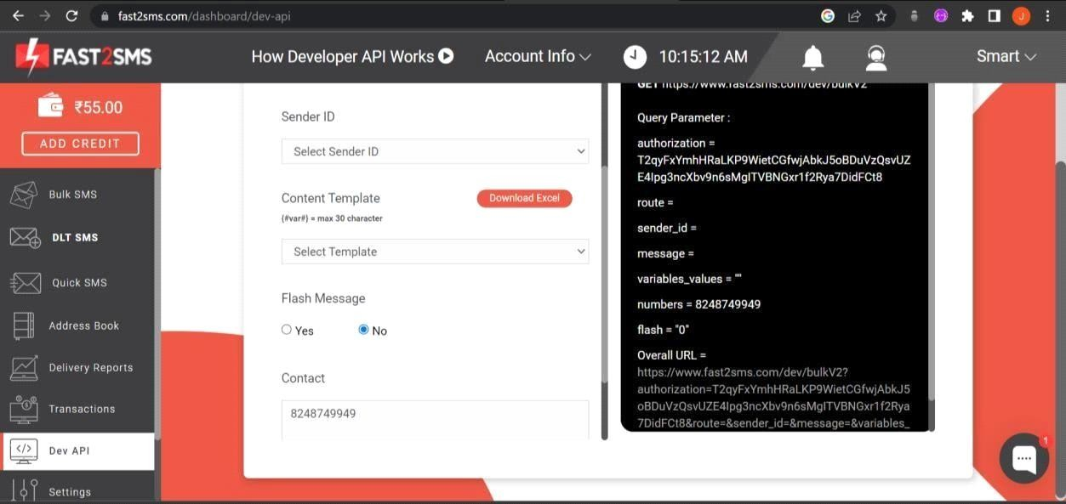# You will receive sms when recharged.